eProsima Dynamic Fast Buffers
Users Manual
Version 0.1



Experts in networking middleware
eProsima © 2013
eProsima
Proyectos y Sistemas de Mantenimiento SL
Ronda del poniente 2 – 1ºG
28760 Tres Cantos Madrid
Tel: + 34 91 804 34 48
info@eProsima.com – www.eProsima.com

Trademarks
eProsima is a trademark of Proyectos y Sistemas SL. All other trademarks used in this document are the property of their respective owners.
License
eProsima Dynamic Fast Buffers is licensed under the therms described in the DYNAMIC_FAST_BUFFERS_LICENSE file included in this distribution.
Technical Support
- Phone: +34 91 804 34 48
- Email: support@eprosima.com
Table of Contents
1 Installation 4
1.1 Windows 7 32-bits 5
1.2 Windows 7 64-bits 6

Installation
This document describes how to install eProsima Dynamic Fast Buffers in several operating systems. Select your operating system and follow the steps.
There is a section in the Choose Components step named “Main Files” that includes all necessary data for the application to work. This component cannot be disabled during the installation, no matter whether 32-bit of 64-bit is selected.
Once the installation is finished, next directories and files will be added inside “Program Files”:
- doc: In this folder, documentation for the application can be found. In the “html” named subfolder all application code documentation is located, while “pdf” folder contains user manual and installation manual.
- Examples: Beneath this folder two Visual Studio 2010 projects are included. Both of them are ready for compilation and proving.
- Include: Header files of eProsima Dynamic Fast Buffers.
- Lib: In this folder there will be located the libraries that conform the applicacion already compiled. 32-bit libraries can be found under “i86Win32VS2010” subfolder and 64-bit libraries under “x64Win64VS2010”.
- DYNAMIC_FAST_BUFFERS_LICENSE.txt: License file for Dynamic Fast Buffers.
- LGPLv3_LICENSE.txt: GNU Lesser Public License text file.
- README.html: HTML file linking to relevant information, including Installation Manual, User Manual and API documentation.
- uninstall.exe: Uninstaller for eProsima DFB library.

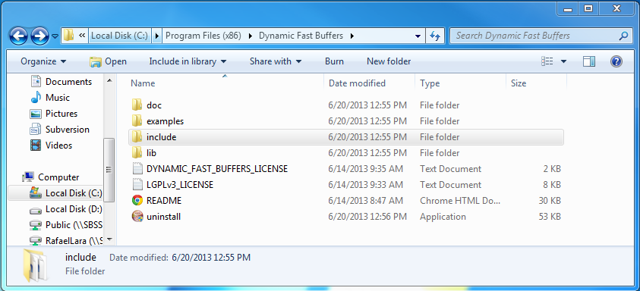

Windows 7 32-bits
- Download the installation package for your system.
eProsima_Dynamic_Fast_Buffers-0.1.exe

- Execute the installer and follow the instructions. You should make sure that “i86 libraries” component is selected in the Choose Components step. Otherwise, installation will not continue.
- A component of eProsima Dynamic Fast Buffers is a dynamic serialization library for basic and complex data types. This library has to be accessible for your system. The environment variable PATH needs to be set to the eProsima Dynamic Fast Buffers i86 library folder. The installer offers the possibility of setting this location in the environment variable PATH. Make sure “i86 libraries location” option is selected in the Choose Components step.

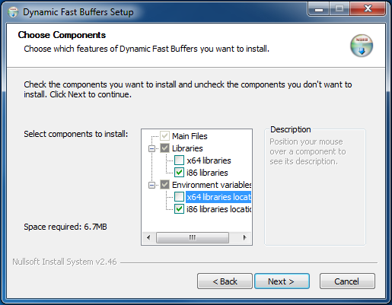

Visual C++ 2010 Redistributable package installation
eProsima Dynamic Fast Buffers requires this package. It can be downloaded from:
Visual C++ 2010 Redistributable

Windows 7 64-bits
- Download the installation package for your system.
- eProsima_Dynamic_Fast_Buffers-0.1.exe

- Execute the installer and follow the instructions. You should make sure that “x64 libraries” component is selected in the Choose Components step. Otherwise, installation will not continue.
- A component of eProsima Dynamic Fast Buffers is a dynamic serialization library for basic and complex data types. This library has to be accessible for your system. The environment variable PATH needs to be set to the eProsima Dynamic Fast Buffers i86 library folder. The installer offers the possibility of setting this location in the environment variable PATH. Make sure “x64 libraries location” option is selected in the Choose Components step.

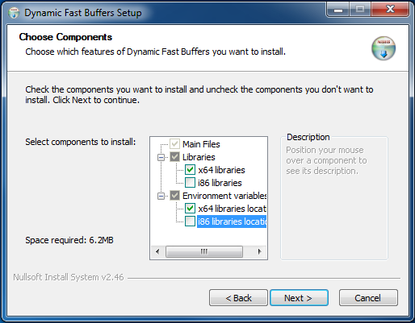

Visual C++ 2010 Redistributable package installation
eProsima Fast Buffers requires this package. It can be downloaded from:
Visual C++ 2010 Redistributable

